MICRO SERVICES
Icic bank login page
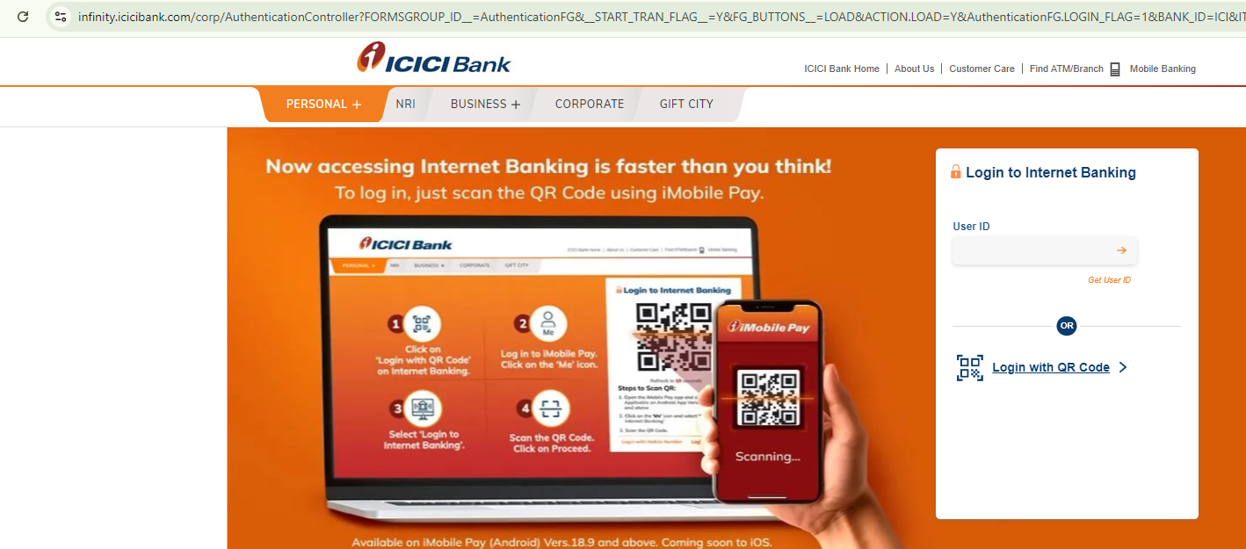
After login successfully navigating to dashboard page.
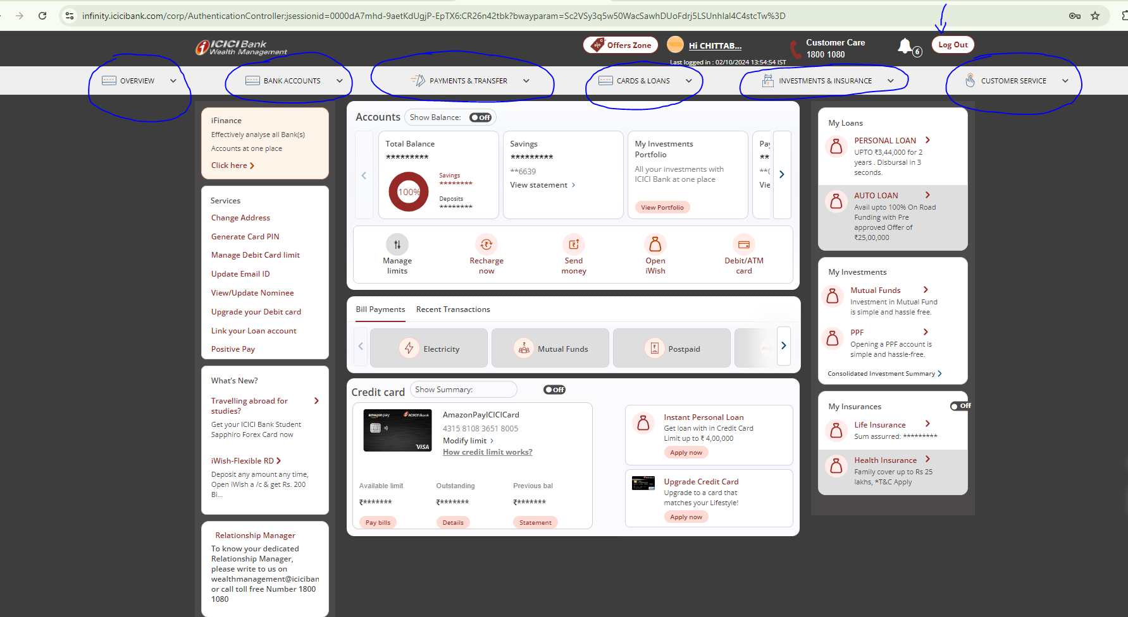
Here 6 menus/MODULES are there.
1)Overview
2)BankAccounts
3)Payments&Transfer
4)Cards&Loans
5)Investments&Insurance
6)CustomerService
1)OverViewMenu pages:
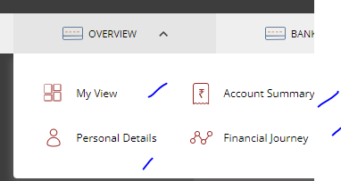
2)BankAccountsMenu
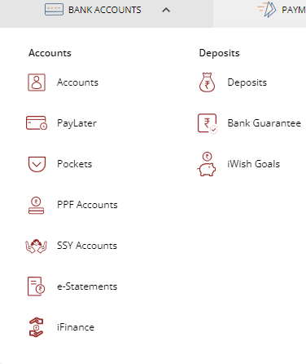
3)Payments&Transfer
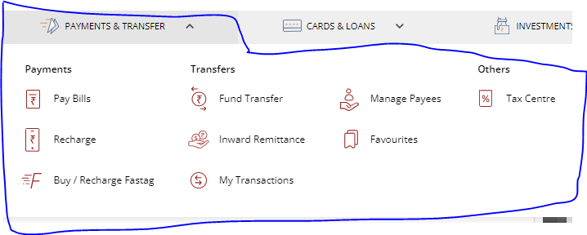
4)Cards&Loans
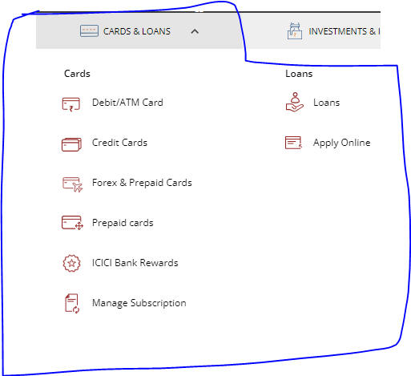
5)Investment&Insurance
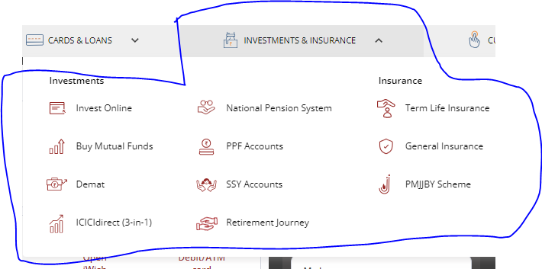
6)Customer Service
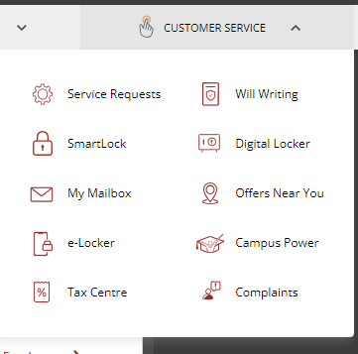

Create database ICICBANKOverview
Create database ICICBANKBankAccounts
Create database ICICBANKPaymentsAndTransfer
Create database ICICBANKCardsAndLoans
Create database ICICBANKInvestmentsAndInsurance
Create database ICICBANKCustomerService

